**DATA BASE MANAGEMENT SYSTEM**

**ER Diagrams:**

* ER diagram or Entity Relationship diagram is a conceptual model that gives the graphical representation of the logical structure of the database.
* It shows all the constraints and relationships that exist among the different components.

**Components of ER diagram:** An ER diagram is mainly composed of following three components-

1. Entity Sets
2. Attributes
3. Relationship Set

**Example:** Consider the following Student table-

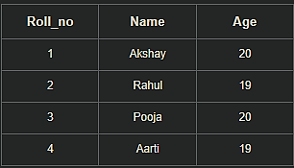

This complete table is referred to as “Student Entity Set” and each row represents an “entity”.

**Representation as ER Diagram:** The above table may be represented as ER diagram as-

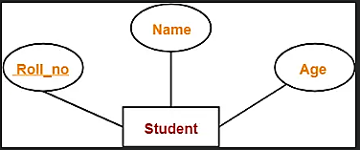

Here,

* Roll_no is a primary key that can identify each entity uniquely.
* Thus, by using student’s roll number, a student can be identified uniquely.

**ER Diagram Symbols:** An ER diagram is composed of several components and each component in ER diagram is represented using a specific symbol.

ER diagram symbols are discussed below-

**1. For Entity Sets-**

An entity set is a set of same type of entities.

An entity refers to any object having-

* Either a physical existence such as a particular person, office, house or car.
* Or a conceptual existence such as a school or a company.

In ER diagram,

* Attributes are associated with an entity set.
* Attributes describe the properties of entities in the entity set.
* Based on the values of certain attributes, an entity can be identified uniquely.

An entity set may be of the following two types-

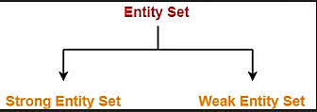

1. Strong entity set
2. Weak entity set

**1. Strong Entity Set-**

* A strong entity set possess its own primary key.
* It is represented using a single rectangle.

**2. Weak Entity Set-**

* A weak entity set do not possess its own primary key.
* It is represented using a double rectangle.

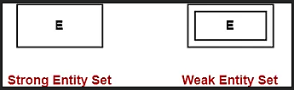

**2. For Relationship Sets-**

* Relationship defines an association among several entities.
* A relationship set is a set of same type of relationships.

A relationship set may be of the following two types-

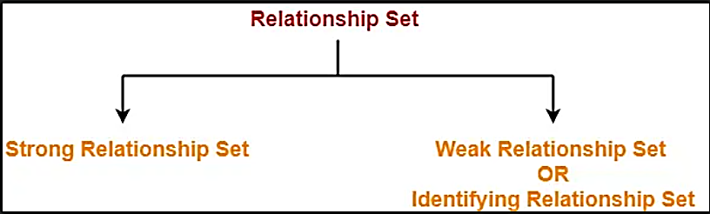

1. Strong relationship set
2. Weak relationship set

**1. Strong Relationship Set-**

* A strong relationship exists between two strong entity sets.
* It is represented using a diamond symbol.

**2. Weak Relationship Set-**

* A weak or identifying relationship exists between the strong and weak entity set.
* It is represented using a double diamond symbol.

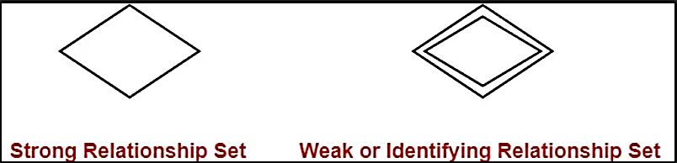

**3. For Attributes-**

* Attributes are the properties which describes the entities of an entity set.
* There are several types of attributes.

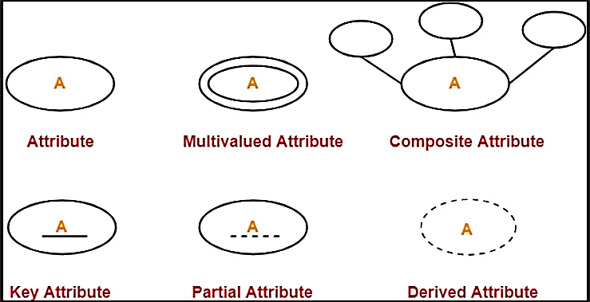

**4. For Participation Constraints-** Participation constraint defines the least number of relationship instances in which an entity has to necessarily participate.

There are two types of participation constraints-

1. Partial participation
2. Total participation

**1. Partial Participation-**

Partial participation is represented using a single line between the entity set and relationship set.

**2. Total Participation-**

Total participation is represented using a double line between the entity set and relationship set.

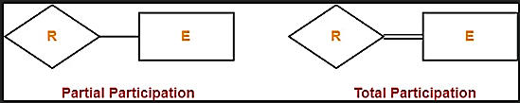

**5. For Specialization and Generalization-**

* Generalization is a process of forming a generalized super class by extracting the common characteristics from two or more classes.
* Specialization is a reverse process of generalization where a super class is divided into sub classes by assigning the specific characteristics of sub classes to them.

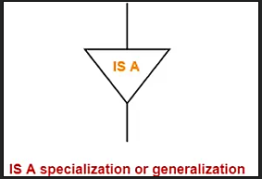

**6. For Cardinality Constraints / Ratios-** Cardinality constraint defines the maximum number of relationship instances in which an entity can participate.

There are 4 types of cardinality ratios-

1. Many-to-many cardinality (m:n)
2. Many-to-one cardinality (m:1)
3. One-to-many cardinality (1:n)
4. One-to-one cardinality (1:1)

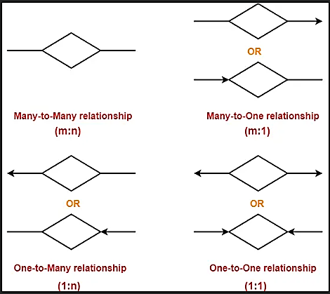

**Entity Sets in DBMS | Strong and Weak entity set**

An entity set is a set of same type of entities.

An entity refers to any object having-

* Either a physical existence such as a particular person, office, house or car.
* Or a conceptual existence such as a school or a company.

In ER diagram,

* Attributes are associated with an entity set.
* Attributes describe the properties of entities in the entity set.
* Based on the values of certain attributes, an entity can be identified uniquely.

An entity set may be of the following two types-



1. Strong entity set
2. Weak entity set

**1. Strong Entity Set-**

* A strong entity set is an entity set that contains sufficient attributes to uniquely identify all its entities.
* In other words, a primary key exists for a strong entity set.
* Primary key of a strong entity set is represented by underlining it.

**Symbols Used-**

* A single rectangle is used for representing a strong entity set.
* A diamond symbol is used for representing the relationship that exists between two strong entity sets.
* A single line is used for representing the connection of the strong entity set with the relationship set.
* A double line is used for representing the total participation of an entity set with the relationship set.
* Total participation may or may not exist in the relationship.

**Example-**

Consider the following ER diagram-

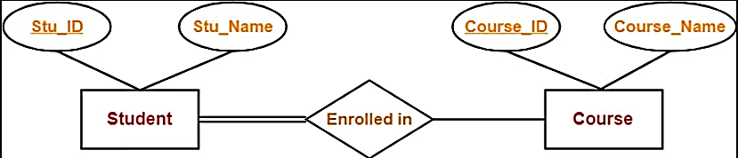

In this ER diagram,

* Two strong entity sets “Student” and “Course” are related to each other.
* Student ID and Student name are the attributes of entity set “Student”.
* Student ID is the primary key using which any student can be identified uniquely.
* Course ID and Course name are the attributes of entity set “Course”.
* Course ID is the primary key using which any course can be identified uniquely.
* Double line between Student and relationship set signifies total participation.
* It suggests that each student must be enrolled in at least one course.
* Single line between Course and relationship set signifies partial participation.
* It suggests that there might exist some courses for which no enrollments are made.

**2. Weak Entity Set-**

* A weak entity set is an entity set that does not contain sufficient attributes to uniquely identify its entities.
* In other words, a primary key does not exist for a weak entity set.
* However, it contains a partial key called as a discriminator.
* Discriminator can identify a group of entities from the entity set.
* Discriminator is represented by underlining with a dashed line.

**NOTE-**

* The combination of discriminator and primary key of the strong entity set makes it possible to uniquely identify all entities of the weak entity set.
* Thus, this combination serves as a primary key for the weak entity set.
* Clearly, this primary key is not formed by the weak entity set completely.

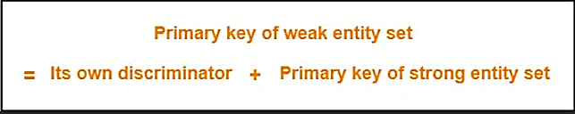

**Symbols Used:**

* A double rectangle is used for representing a weak entity set.
* A double diamond symbol is used for representing the relationship that exists between the strong and weak entity sets and this relationship is known as identifying relationship.
* A double line is used for representing the connection of the weak entity set with the relationship set.
* Total participation always exists in the identifying relationship.

**Example-**

Consider the following ER diagram-

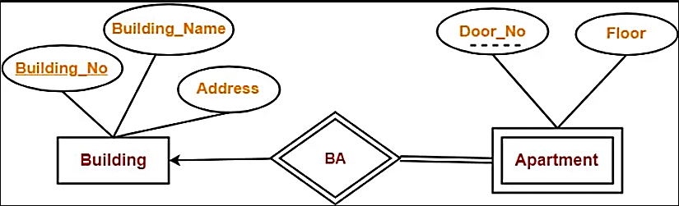

In this ER diagram,

* One strong entity set “Building” and one weak entity set “Apartment” are related to each other.
* Strong entity set “Building” has building number as its primary key.
* Door number is the discriminator of the weak entity set “Apartment”.
* This is because door number alone can not identify an apartment uniquely as there may be several other buildings having the same door number.
* Double line between Apartment and relationship set signifies total participation.
* It suggests that each apartment must be present in at least one building.
* Single line between Building and relationship set signifies partial participation.
* It suggests that there might exist some buildings which has no apartment.

To uniquely identify any apartment,

* First, building number is required to identify the particular building.
* Secondly, door number of the apartment is required to uniquely identify the apartment.

Thus,

Primary key of Apartment

= Primary key of Building + Its own discriminator

= Building number + Door number

**Differences between Strong entity set and Weak entity set-**

|  |  |
| --- | --- |
| **Strong entity set** | **Weak entity set** |
| A single rectangle is used for the representation of a strong entity set. | A double rectangle is used for the representation of a weak entity set. |
| It contains sufficient attributes to form its primary key. | It does not contain sufficient attributes to form its primary key. |
| A diamond symbol is used for the representation of the relationship that exists between the two strong entity sets. | A double diamond symbol is used for the representation of the identifying relationship that exists between the strong and weak entity set. |
| A single line is used for the representation of the connection between the strong entity set and the relationship. | A double line is used for the representation of the connection between the weak entity set and the relationship set. |
| Total participation may or may not exist in the relationship. | Total participation always exists in the identifying relationship. |

**Important Note-**

In ER diagram, weak entity set is always present in total participation with the identifying relationship set.

So, we always have the picture like shown here-

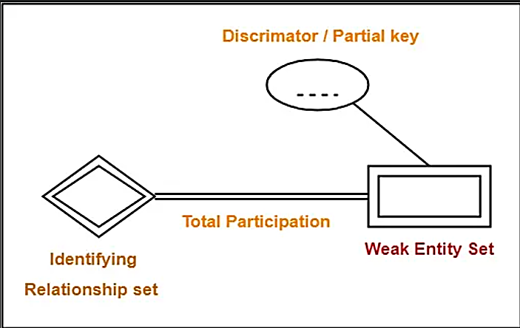

**Relationship in DBMS**

A relationship is defined as an association among several entities.

Example: ‘Enrolled in’ is a relationship that exists between entities Student and Course.

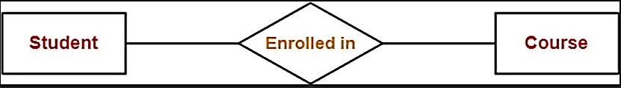

**Relationship Set-**

A relationship set is a set of relationships of same type.

**Example-**

Set representation of above ER diagram is-

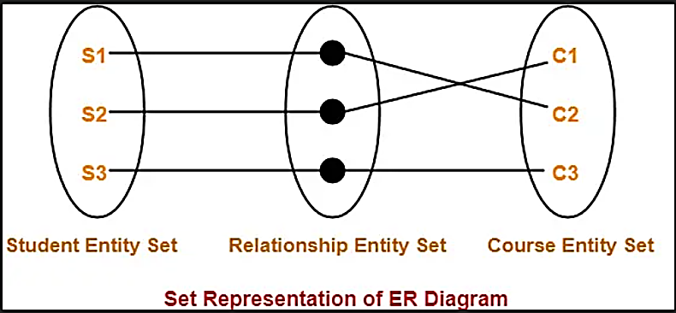

**Degree of a Relationship Set-**

The number of entity sets that participate in a relationship set is termed as the degree of that relationship set. Thus,

Degree of a relationship set = Number of entity sets participating in a relationship set

**Types of Relationship Sets-**

On the basis of degree of a relationship set, a relationship set can be classified into the following types-

1. Unary relationship set
2. Binary relationship set
3. Ternary relationship set
4. N-ary relationship set

**1. Unary Relationship Set**

Unary relationship set is a relationship set where only one entity set participates in a relationship set.

**Example-**

One person is married to only one person

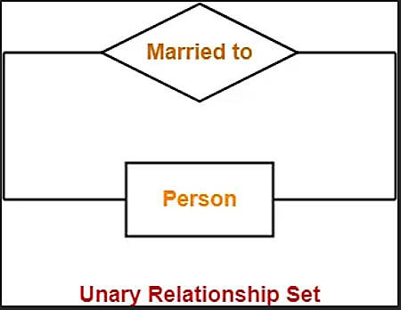

**2. Binary Relationship Set-**

Binary relationship set is a relationship set where two entity sets participate in a relationship set.

**Example-**

Student is enrolled in a Course

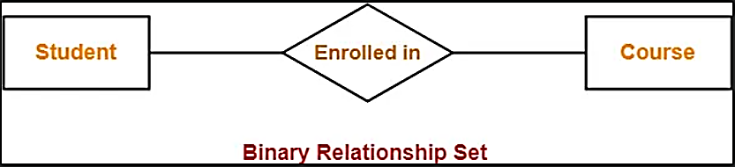

**3. Ternary Relationship Set-**

Ternary relationship set is a relationship set where three entity sets participate in a relationship set.

**Example-**

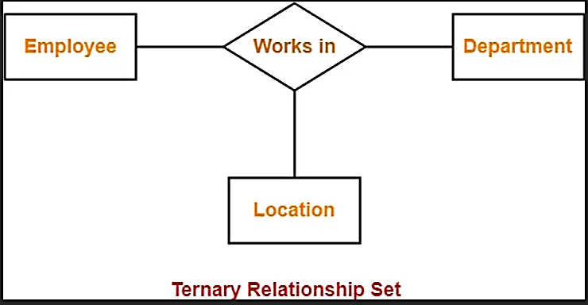

**4. N-ary Relationship Set-**

N-ary relationship set is a relationship set where ‘n’ entity sets participate in a relationship set.

**Cardinality in ER Diagram | DBMS**

**Cardinality Constraint-** Cardinality constraint defines the maximum number of relationship instances in which an entity can participate.

**Types of Cardinality Ratios**-

There are 4 types of cardinality ratios-

1. Many-to-Many cardinality (m:n)
2. Many-to-One cardinality (m:1)
3. One-to-Many cardinality (1:n)
4. One-to-One cardinality (1:1 )

**1. Many-to-Many Cardinality-**

By this cardinality constraint,

* An entity in set A can be associated with any number (zero or more) of entities in set B.
* An entity in set B can be associated with any number (zero or more) of entities in set A.

**Symbol Used-**

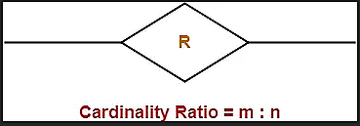

**Example-**

Consider the following ER diagram-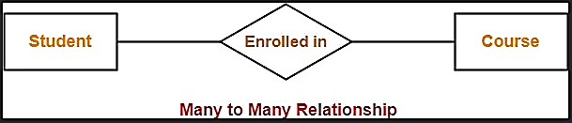

Here,

* One student can enroll in any number (zero or more) of courses.
* One course can be enrolled by any number (zero or more) of students.

**2. Many-to-One Cardinality-**

By this cardinality constraint,

* An entity in set A can be associated with at most one entity in set B.
* An entity in set B can be associated with any number (zero or more) of entities in set A.

**Symbol Used-**

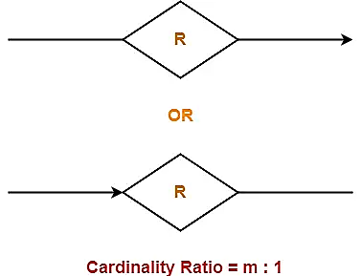

**Example-**

Consider the following ER diagram-

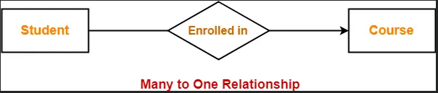

Here,

* One student can enroll in at most one course.
* One course can be enrolled by any number (zero or more) of students.

**3. One-to-Many Cardinality-**

By this cardinality constraint,

* An entity in set A can be associated with any number (zero or more) of entities in set B.
* An entity in set B can be associated with at most one entity in set A.

**Symbol Used-**

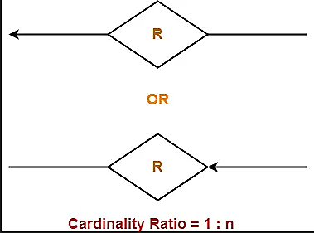

**Example-**

Consider the following ER diagram-

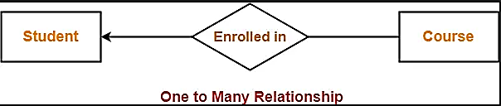

Here,

* One student can enroll in any number (zero or more) of courses.
* One course can be enrolled by at most one student.

**4. One-to-One Cardinality-**

By this cardinality constraint,

* An entity in set A can be associated with at most one entity in set B.
* An entity in set B can be associated with at most one entity in set A.

**Symbol Used-**

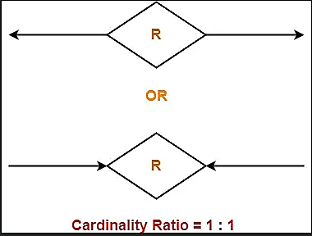

**Example-**

Consider the following ER diagram-

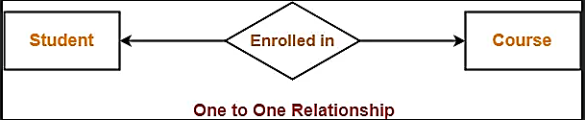

Here,

* One student can enroll in at most one course.
* One course can be enrolled by at most one student.

**Participation Constraints**

Participation constraints define the least number of relationship instances in which an entity must compulsorily participate.

**Types of Participation Constraints-**

There are two types of participation constraints-

1. Total participation
2. Partial participation

**1. Total Participation-**

* It specifies that each entity in the entity set must compulsorily participate in at least one relationship instance in that relationship set.
* That is why, it is also called as mandatory participation.
* Total participation is represented using a double line between the entity set and relationship set.

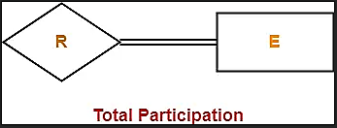

**Example-**

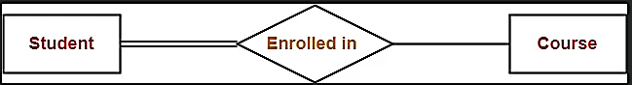

Here,

* Double line between the entity set “Student” and relationship set “Enrolled in” signifies total participation.
* It specifies that each student must be enrolled in at least one course.

**2. Partial Participation-**

* It specifies that each entity in the entity set may or may not participate in the relationship instance in that relationship set.
* That is why, it is also called as optional participation.
* Partial participation is represented using a single line between the entity set and relationship set.

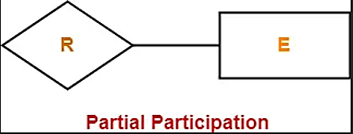

**Example-**

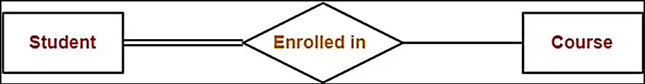

Here,

* Single line between the entity set “Course” and relationship set “Enrolled in” signifies partial participation.
* It specifies that there might exist some courses for which no enrollments are made.

**Relationship between Cardinality and Participation Constraints-**

Minimum cardinality tells whether the participation is partial or total.

* If minimum cardinality = 0, then it signifies partial participation.
* If minimum cardinality = 1, then it signifies total participation.

Maximum cardinality tells the maximum number of entities that participates in a relationship set.

**Attributes in ER Diagram**

* Attributes are the descriptive properties which are owned by each entity of an Entity Set.
* There exist a specific domain or set of values for each attribute from where the attribute can take its values.

**Types of Attributes-**

In ER diagram, attributes associated with an entity set may be of the following types-

1. Simple attributes
2. Composite attributes
3. Single valued attributes
4. Multi valued attributes
5. Derived attributes
6. Key attributes

**1. Simple Attributes-**

Simple attributes are those attributes which can not be divided further.

**Example-**

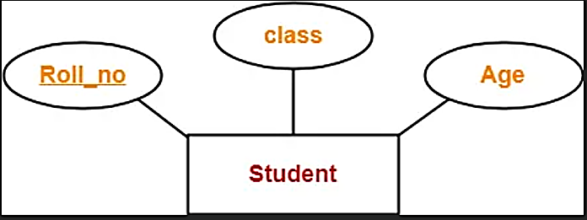

Here, all the attributes are simple attributes as they can not be divided further.

**2. Composite Attributes-**

Composite attributes are those attributes which are composed of many other simple attributes.

**Example-**

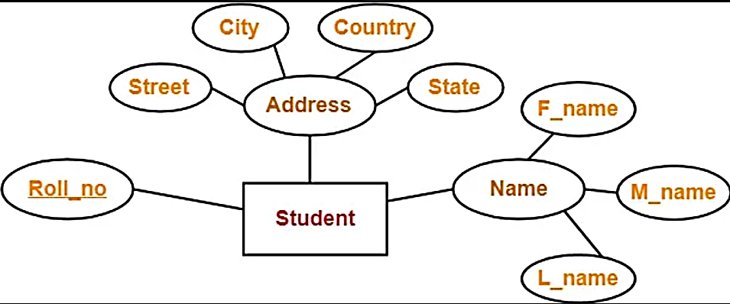

Here, the attributes “Name” and “Address” are composite attributes as they are composed of many other simple attributes.

**3. Single Valued Attributes-**

Single valued attributes are those attributes which can take only one value for a given entity from an entity set.

**Example-**

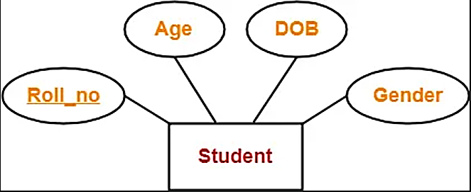

Here, all the attributes are single valued attributes as they can take only one specific value for each entity.

**4. Multi Valued Attributes-**

Multi valued attributes are those attributes which can take more than one value for a given entity from an entity set.

**Example-**

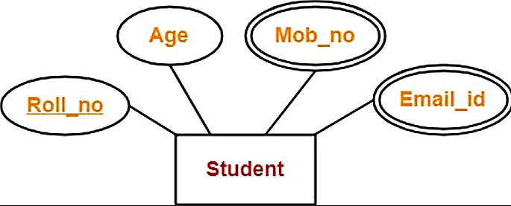

Here, the attributes “Mob_no” and “Email_id” are multi valued attributes as they can take more than one values for a given entity.

**5. Derived Attributes-**

Derived attributes are those attributes which can be derived from other attribute(s).

**Example-**

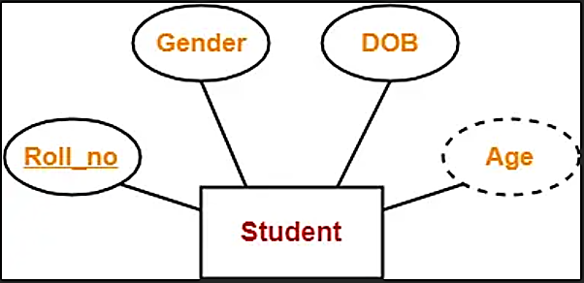

Here, the attribute “Age” is a derived attribute as it can be derived from the attribute “DOB”.

**6. Key Attributes-**

Key attributes are those attributes which can identify an entity uniquely in an entity set.

**Example-**



Here, the attribute “Roll_no” is a key attribute as it can identify any student uniquely.